Sports Corner Online Shopping Website
Maaz Wangde  Dept. of information technology  Bharati Vidyapeeth College of Engineering, Kharghar Navi Mumbai, India  e-mail: wangdemaaz121@gmail.com | Akash Vhotkar  Dept. of information technology  Bharati Vidyapeeth College of Engineering, Kharghar Navi Mumbai, India  e-mail: akashvhotkar4@gmail.com | Shubham Surve  Dept. of information technology  Bharati Vidyapeeth College of Engineering, Kharghar Navi Mumbai, India  e-mail: surveshubham10@gmail.com | Pravin Patel  Dept. of information technology  Bharati Vidyapeeth College of Engineering, Kharghar Navi Mumbai, India  e-mail: pravinpatel@gmail.com

Abstract— Online shopping is an easy and comfortable way of shopping from a large range of products. There are innumerable advantages of online shopping. Customers can save a lot of time which they normally need to physically go to the retail shop and buy the products that customers want. In this digital era consumers prefer online shopping to save time. But in their busy schedules it can be time-consuming to choose items as per their requirements. The two main key features are online payment system which we are going to implement using stripe and live tracking of orders for which we are using sockets Other than we are planning to implement login and register page with proper validation and authentication. In the cart page there will a input select for choosing the products and adding them to the cart and also update functionality to update cart products.
Keywords—E-commerce , Node Js, React Js, Payment, Live Tracking Of Orders .

Introduction

This projects aims to develop an online shopping for customers where they will be able to buy their favourite sports related products. With the help of this you can carry out an online shopping from your home. Here is no compelling reason to go to the crowded stores or shopping canters during festival seasons especially during these tough covid times, it is better to shop online rather than going out to buy. You simply require a PC or a laptop and one important payment sending option to shop online. You will have a wide variety of sports products to pick from which are of reasonable price and highest quality. In this project we will be implementing online payment system as well so that that the process is faster and convenient to the user.
SPORTS CORNER a online shopping website where users would be able to buy sports products over the internet at affordable price.
The number of online shoppers has increased in recent years. indicated that more than 60% of American consumers shop online at least once a month; only 1% has never shopped online. in the past 12 months, more than 70% German and Finnish users have used the Internet to shop, and over 80% English users shop online. Here is high scope of e-commerce in each aspect of business, at present it is in the embryonic stage but in future e-commerce would be the part of day to day activity of business firms.
Marketing areas where we seek scope of e-commerce includes Marketing, sales and sales, promotion.Presales , subcontracts, supply, Financing and insurance ,Commercial transactions ordering, delivery, payment,product service and maintenance, Co-operative product development,distributed co-operative working ,Use of public and private services Business-to-administrations,Transport and logistics,Public procurement,Automatic trading of digital goods like games, learning material, songs and music etc,Accounting and financial management,Legal advice.
Need of Work
- The purpose of online shopping is to save time, save money.
- Through online shopping one can save his valuable time.
- One can watch and select things he wants to buy.
- Through online shopping we can save our money because prices are less than market prices and we receive our bought things at our home.
- In these case you can buy any sports items of our choice that too with low price and high quality also you can sell your wanted sports items.

DeSign Methods
For consulting firms to effectively develop E-Commerce strategies for its clients, it must have a structured methodology custom made for this type of project. As with any methodology, however, this E-Commerce strategy methodology will require constant refinement to incorporate new experiences and to keep pace with change.
Thus, this project aims to develop the first version of an E-Commerce strategy methodology, implement the methodology for a client, and make any necessary revisions to the methodology subsequent to the client project.

Design methodology
The five phases of the project are as follows:
Scoping and planning
This phase focuses on the planning of the project’s overall direction, including the definition of the project’s scope, objectives, and timelines. The deliverable from this phase is this Design Plan.
Conceptual design and research
In this phase, the conceptual design of the methodology is developed and research on existing methodologies is conducted. Research is performed from independent research firms, such as the Gartner Group, Forrester Research, and CIO.com. These research firms sometimes publish the methodologies that consulting firms use. Consulting firms’ websites are another source for researching E-commerce strategy methodologies.
Development of methodology
The actual methodology is developed in this phase. Detailed descriptions of each task in the methodology are documented, including the objectives, inputs, approach, relevant models, applicable tools and techniques, outputs, and any references. The methodology is to be documented in an appropriate format, be it a Word document or HTML pages.
Implementation of methodology
The methodology will be implemented with a client. This phase includes the marketing of E-commerce strategy development services and the closing of the sale, followed by the actual implementation.
Revision of methodology
Final touches and revisions to the methodology are made in this phase. The majority of these revisions come from experiences on the client project. Sample reports and any additional references are added to the methodology.

Related works

There have been study done previously aiming to find out the problems that are generally faced by a customer during online purchase and the relevant factors due to which customers do not prefer online shopping. Descriptive research design has been used for the study. Descriptive research studies are those that are concerned with describing the characteristics of a particular individual or group. This study targets the population drawn from customers who have purchased from online stores. Most of the respondents participated were post graduate students and and educators.

The total population size was indefinite and the sample size used for the study was 158. A total of 170 questionnaires were distributed among various online users, out of which 12 questionnaires were received with incomplete responses and were excluded from the analysis. The respondents were selected based on the convenient sampling technique. The primary data were collected from Surveys with the help of self-administered questionnaires.

The close-ended questionnaire was used for data collection so as to reduce the non-response rate and errors. The questionnaire consists of two different sections, in which the first section consists of the introductory questions that gives the details of socio-economic profile of the consumers as well as their behaviour towards usage of internet, time spent on the Web, shopping sites preferred while making the purchase, and the second section consist of the questions related to the research question.
To investigate the factors restraining consumer purchase, five-point Likert scale with response ranges from “Strongly agree” to “Strongly disagree”, with following equivalencies, “strongly disagree” = 1, “disagree” = 2, “neutral” = 3, “agree” = 4 and “strongly agree” = 5 was used in the questionnaire with total of 28 items. After collecting the data, it was manually recorded on the Excel sheet. For analysis socio-economic profile descriptive statistics was used and factors analysis was performed on SPSS for factor reduction.

Future Works
In future, the behavior of the customer while shopping in both modes online and offline should explore and critically analyze. Also the analysis should be done that how much customers with low level literacy or internet knowledge will adopt the shopping. After that research outcomes will be more realistic approach.

System Architecture
Our two main key features are online payment system which we are going to implement using stripe and live tracking of orders for which we are using sockets. Other than we are planning to implement login and register page with proper validation and authentication. In the cart page there will a input select for choosing the products and adding them to the cart and also update functionality to update cart products.
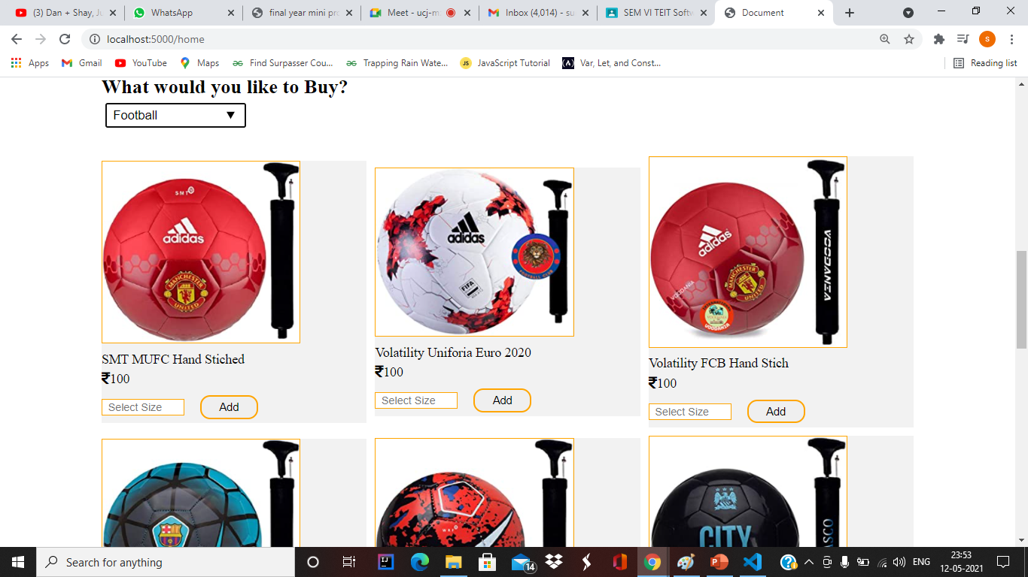

E-commerce is based on the client-server architecture. A client can be an application, which uses a Graphical User Interface (GUI) that sends request to a server for certain services. The server is the provider of the services requested by the client. In E-commerce, a client refers to a customer who requests for certain services and the server refers to the business application through which the services are provided. The business application that provides services is deployed on a Web' server. The E - Commerce Web server is a computer program that provides services to "other computer programs and serves requested Hyper Text Mark-up Language (HTML) pages or files. In client-server architecture, a machine can be both a client as well as a server.
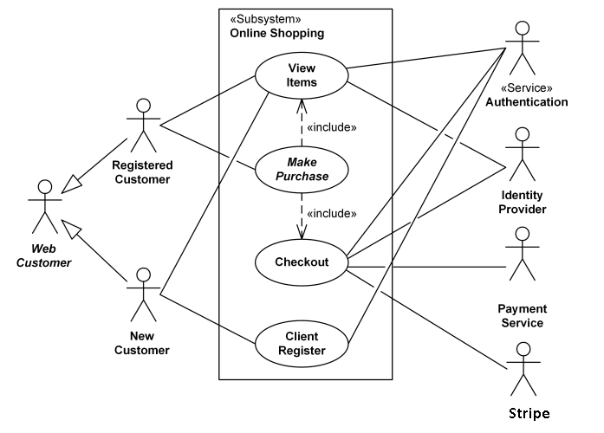
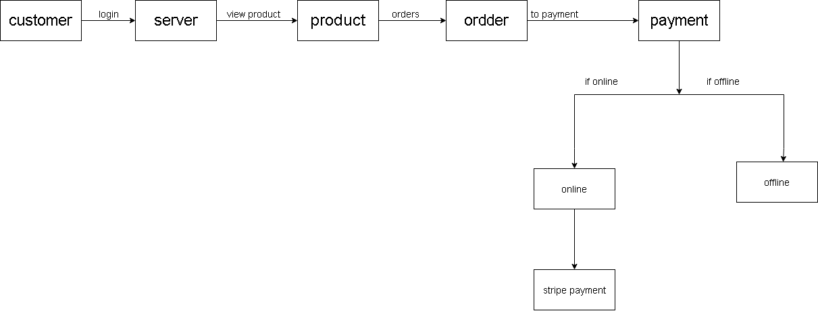

Acknowledgement

We would like to thank our mentor P.A. PATEl Dept. of information technology Bharati Vidyapeeth College of Engineering, Kharghar Navi Mumbai, India.

References
1) Author: Dimira Teneva https://www.metrilo.com/blog/important-ecommerce-metrics
2) Author : Gérson Tontini FURB - Regional University of Blumenau, https://www.researchgate.net/publication/301705470_Identifying_opportunities_for_improvement_in_online_shopping_sites
3) Author : Aladwani, A. M.,& Palvia, Developing and validating an instrument for measuring user-perceived web quality. Information & Management, 396, 467-476. doi:10.1016/S0378-72060100113-6. https://dl.acm.org/doi/
[1] W. W. Hill and S. E. Beatty, "A model of adolescents' online
consumer self-efficacy (OCSE)," Journal of Business Research, vol. 64, pp.
1025-1033, 2011.
[2] J. Kim and S. Forsythe, "Factors affecting adoption of product
virtualization technology for online consumer electronics shopping,"
International Journal of Retail & Distribution Management, vol. 38, pp. 190-
204, 2010.
[3] J. Lian and T. Lin, "Effects of consumer characteristics on their
acceptance of online shopping: Comparisons among different product
types,"Comput. Hum. Behav., vol. 24, pp. 48-65, 2008.
[4] J. Carlos Roca, J. Jos Garca and Jos de la Vega, Juan, "The
importance of perceived trust, security and privacy in online trading
systems,"Information Management & Computer Security, vol. 17, pp. 96-113,
2009.
[5] S. Wu, "The relationship between consumer characteristics and
attitude toward online shopping," Marketing Intelligence & Planning, vol. 21,
pp. 37-44, 2003.
[6] P. Zhang and N. Li, "Consumer online shopping attitudes and
behavior: An assessment of research," in Proceedings of the Americas
Conference on Information Systems (AMCIS’2002), Dallas, 2002, .
[7] Retail Industry Global Report – 2010&nbsp;. Available:
http://www.clearwatercf.com/documents/sectors/IMAP_Retail_Report_2010.
pdf
[8] E-commerce 2009 [online]. Available:
http://www.census.gov/econ/estats/2009/2009reportfinal.pdf
[9] Internet purchases by individuals [online]. Available:
http://appsso.eurostat.ec.europa.eu/nui/setupModifyTableLayout.do
[10] J. Prez-Hernndez and R. Snchez-Mangas, "To have or not to have
Internet at home: Implications for online shopping," Information Economics
and Policy, vol. 23, pp. 213-226, 2011.

